What Is Biochar?

Biochar Is a Valuable Soil Amendment
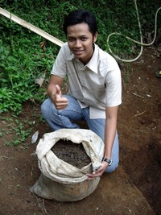
Biochar is a 2,000 year-old practice that converts agricultural waste into a soil enhancer that can hold carbon, boost food security and discourage deforestation. The process creates a fine-grained, highly porous charcoal that helps soils retain nutrients and water.
Biochar is found in soils around the world as a result of vegetation fires and historic soil management practices. Intensive study of biochar-rich dark earths in the Amazon (terra preta), has led to a wider appreciation of biochar’s unique properties as a soil enhancer.
Biochar can be an important tool to increase food security and cropland diversity in areas with severely depleted soils, scarce organic resources, and inadequate water and chemical fertilizer supplies.
Biochar also improves water quality and quantity by increasing soil retention of nutrients and agrochemicals for plant and crop utilization. More nutrients stay in the soil instead of leaching into groundwater and causing pollution.

Biochar is a Powerfully Simple Tool to Combat Climate Change
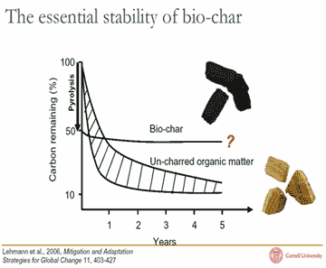
The carbon in biochar resists degradation and can hold carbon in soils for hundreds to thousands of years. Biochar is produced through pyrolysis or gasification — processes that heat biomass in the absence (or under reduction) of air.
In addition to creating a soil enhancer, sustainable biochar practices can produce oil and gas byproducts that can be used as fuel, providing clean, renewable energy. When the biochar is buried in the ground as a soil enhancer, the system can become "carbon negative."
Biochar and bioenergy co-production can help combat global climate change by displacing fossil fuel use and by sequestering carbon in stable soil carbon pools. It may also reduce emissions of nitrous oxide.
We can use this simple, yet powerful, technology to store 2.2 gigatons of carbon annually by 2050. It’s one of the few technologies that is relatively inexpensive, widely applicable, and quickly scalable. We really can’t afford not to pursue it.
Processing:
Cover organic waste with a plastic foil, add Urine, Dung from cows; also charcoal. See Internet for more Details about that

Frequently Asked Questions about Biochar
- What is biochar?
- What can biochar do?
- How is biochar produced?
- How do we know that biochar helps increase crop yields?
- How can biochar help farmers?
- How does biochar affect soil biology?
- How does biochar affect soil properties like pH and CEC?
- Can you add biochar to alkaline soils?
- How long does biochar last in the soil?
- How much CO₂ can biochar potentially remove from the atmosphere?
- How does biochar work to reduce emissions of greenhouse gases other than CO₂?
- Is biochar production sustainable?
- Does IBI advocate adding carbon derived from coal, old tires or municipal solid waste to soils?
- Could biochar impact climate through changes in soil albedo?
- Could black dust from biochar have an impact on climate?
- What are the costs and benefits of producing and using biochar?
- Can biochar be patented?
- Does the rise or fall of the biochar industry depend on comprehensive international agreements on climate change?
- Can IBI provide more information on purchasing biochar?
- How can I find help using biochar for my crops and the soils in my specific location?
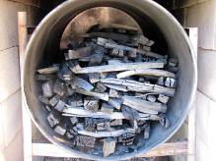
Biochar in the kiln. Photo courtesy of Kelpie Wilson
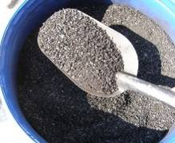
Biochar made from bones in a carrier for potting soils. Photo courtesy of Edward Someus.
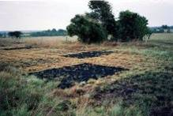
Field trials in Colombia with different concentrations of biochar. Photo courtesy of Julie Major.
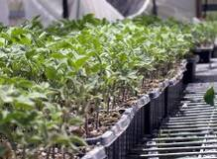
Biochar pot trials in the greenhouse. Photo courtesy of Edward Someus.

1. What is biochar?
Biochar is the carbon (C) rich product when biomass, such as wood, manure or leaves, is heated with little or no available air. In more technical terms, biochar is produced by thermal decomposition of organic material under limited supply of oxygen (O₂), and at relatively low temperatures (<700°C). This process often mirrors the production of charcoal, which is perhaps the most ancient industrial technology developed by humankind. However, it distinguishes itself from charcoal and similar materials by the fact that biochar is produced with the intent to be applied to soil as a means to improve soil health, to filter and retain nutrients from percolating soil water, and to provide carbon storage.
See Chapter 1: Biochar for Environmental Management – an Introduction, Biochar for Environmental Management: Science and Technology, edited by Johannes Lehmann and Stephen Joseph, Earthscan 2009.

2. What can biochar do?
Sustainable biochar is a powerfully simple tool that can 1) fight global warming; 2) produce a soil enhancer that holds carbon and makes soil more fertile; 3) reduce agricultural waste; and 4) produce clean, renewable energy. In some biochar systems all four objectives can be met, while in others a combination of two or more objectives will be obtained.
See Chapter 1: Biochar for Environmental Management – an Introduction, Biochar for Environmental Management: Science and Technology, edited by Johannes Lehmann and Stephen Joseph, Earthscan 2009.

3. How is biochar produced?
Biochar can be made in many different ways, primarily using one of three dominant processes of thermal decomposition: pyrolysis, gasification and hydrothermal carbonization. Energy products in the form of gas or oil are produced along with the biochar. These energy products may be recoverable for another use, or may simply be burned and released as heat. In addition, biochar can be made from a wide variety of biomass feedstocks. As a result, very different biochar systems emerge on different scales. These systems may use production technologies that do or do not produce recoverable energy as well as biochar, and range from small household units to large bioenergy power plants.
See Chapter 8: Biochar Production Technology and Chapter 9: Biochar Systems, in Biochar for Environmental Management: Science and Technology, edited by Johannes Lehmann and Stephen Joseph, Earthscan 2009.

4. How do we know that biochar helps increase crop yields?
There is a large body of peer-reviewed literature quantifying and describing the crop yield benefits of biochar-amended soil. Field trials using biochar have been conducted in the tropics over the past several years. All showed positive results on yields when biochar was applied to field soils and nutrients were managed appropriately. Large scale field trials have recently begun on highly fertile Iowa Mollisols by the US Department of Agriculture’s Agricultural Research Service (USDA-ARS). First year results are positive, yet it will take several years before definitive results are available (Laird, D., 2009)
There is also evidence from thousands of years of traditional use of charcoal in soils. The most well-know example is the fertile Terra Preta soils in Brazil, but Japan also has a long tradition of using charcoal in soil, a tradition that is being revived and has been exported over the past 20 years to countries such as Costa Rica. The Brazilian and Japanese traditions together provide long-term evidence of positive biochar impact on soils.
While the larger questions concerning overall biochar benefits to soils and climate have been answered in the affirmative, significant questions remain, including the need for a better understanding of some of the details of biochar production and characterization. Work is ongoing to develop methods for matching different types of biochar to soils for the best results. IBI is working with private and public researchers around the world to develop protocols to answer these questions.
***T
For more information see IBI’s research summary: Soil Improvement from Application of Biochar

5. How can biochar help farmers?
Biochar provides a unique opportunity to improve soil fertility for the long term using locally available materials. Used alone, compost, manure or agrochemicals must be added at the same rate every year in order to realize benefits. Application rates can be reduced when nutrients are combined with biochar. Biochar remains in the soil, and single applications provide benefits over many years. Farmers can also receive an energy yield when converting organic residues into biochar by capturing energy given off in the biochar production process. In both industrialized and developing countries, soil loss and degradation is occurring at unprecedented rates, with profound consequences for soil ecosystem properties. In many regions, loss in soil productivity occurs despite intensive use of agrochemicals, concurrent with adverse environmental impacts on soil and water resources. Biochar can play a major role in expanding options for sustainable soil management by improving upon existing best management practices, not only to improve soil productivity but also to decrease nutrient loss through leaching by percolating water.
See Chapter 1: Biochar for Environmental Management – an Introduction, in Biochar for Environmental Management: Science and Technology, edited by Johannes Lehmann and Stephen Joseph, Earthscan 2009.

6. How does biochar affect soil biology?
Decades of research in Japan and recent studies in the U.S. have shown that biochar stimulates the activity of a variety of agriculturally important soil microorganisms, and can greatly affect the microbiological properties of soils. The pores in biochar provide a suitable habitat for many microorganisms by protecting them from predation and drying while providing many of their diverse carbon (C), energy and mineral nutrient needs. With the interest in using biochar for promoting soil fertility, many scientific studies are being conducted to better understand how this affects the physical and chemical properties of soil and its suitability as a microbial habitat. Since soil organisms provide a myriad of ecosystem services, understanding how adding biochar to soil may affect soil ecology is critical for assuring that soil quality and the integrity of the soil subsystem are maintained.
See Chapter 6: Characteristics of Biochar: Biological Properties, in Biochar for Environmental Management: Science and Technology, edited by Johannes Lehmann and Stephen Joseph, Earthscan 2009.

7. How does biochar affect soil properties like pH and CEC?
In most agricultural situations worldwide, soil pH (a measure of acidity) is low (low pH means acid soil) and needs to be increased. Biochar retains nutrients in soil directly through the negative charge that develops on its surfaces, and this negative charge can buffer acidity in the soil (as does organic matter in general). Not only the pH of biochar but also the amount and nature of the ash it contains can have an effect on pH after soil application. In fact, ash added along with biochar can react in soil similarly to agricultural lime. Not all biochar materials have a high pH; it is also possible to control the pH of biochar by controlling the pyrolysis process. However, other desirable properties of the material such as surface area and CEC become greater as the temperature of the process (and the pH) increase.
CEC stands for Cation Exchange Capacity, and is one of many factors involved in soil fertility. “Cations” are positively charged ions, in this case we refer specifically to plant nutrients such as calcium (Ca²⁺), potassium (K⁺), magnesium (Mg²⁺) and others. These simple forms are those in which plants take the nutrients up through their roots. Organic matter and some clays in soil hold on to these positively charged nutrients because they have negatively charged sites on their surfaces, and opposite charges attract. The soil can then “exchange” these nutrients with plant roots. If a soil has a low cation exchange capacity, it is not able to retain such nutrients well, and the nutrients are often washed out with water. Biochar develops negative charges on the large surface area contained in its pores, and thus, when added to soil, provides more negatively charged sites for cations to be retained on and exchanged from.
See Chapter 14: Biochar effects on soil nutrient transformations; Chapter 15: Biochar effects on nutrient leaching; and Chapter 16: Biochar and Sorption of Organic Compounds, in Biochar for Environmental Management: Science and Technology, edited by Johannes Lehmann and Stephen Joseph, Earthscan 2009.

8. Can you add biochar to alkaline soils?
Most biochar trials have been done on acidic soils, where biochars with a high pH (e.g. 6 – 10) were used. One study that compared the effect of adding biochar to an acidic and an alkaline soil found greater benefits on crop growth in the acidic soil, while benefits on the alkaline soil were minor. In another study, adding biochar to soil caused increases in pH which had a detrimental effect on yields, because of micronutrient deficiencies which occur at high pH (>6). Care must be taken when adding any material with a liming capacity to alkaline soils; however, it is possible to produce biochar that has little or no liming capacity that is suitable for alkaline soils.
See Chapter 5 Biochar: Nutrient Properties and Their Enhancement, in Biochar for Environmental Management: Science and Technology, edited by Johannes Lehmann and Stephen Joseph, Earthscan 2009.

9. How long does biochar last in the soil?
The stability of biochar is of fundamental importance in determining the environmental benefits of biochar. There are two reasons why stability is important: first, stability determines how long carbon (C) applied to soil as biochar will remain sequestered in soil and contribute to the mitigation of climate change; and secondly, stability will determine how long biochar can provide benefits to soil and water quality. Biochar is not a single material, and its characteristics vary depending upon what it is made from and how it is made. Most biochars have a small labile (easily decomposed) fraction in addition to a much larger stable fraction. Scientists have shown that the mean residence time of this stable fraction is estimated to range from several hundred to a few thousand years. Generally, in temperate regions, organic matter decomposes more slowly than in the tropics, so we would expect longer residence times there.
For more information see IBI’s research summary: Biochar Recalcitrance in Soil
See Chapter 11: Stability of Biochar in Soil, in Biochar for Environmental Management: Science and Technology, edited by Johannes Lehmann and Stephen Joseph, Earthscan 2009.

10. How much CO₂ can biochar potentially remove from the atmosphere?
The IBI promotes the use of waste biomass for the production of biochar. Large amounts of agricultural residues, municipal green waste and forestry biomass are currently burned or left to decompose and release CO₂ and methane back into the atmosphere.
IBI has produced a preliminary analysis of several different carbon offset scenarios titled, “How Much Carbon Can Biochar Systems Offset--and When?” based on using only biomass from waste streams. Even a conservative scenario, using only 27% of the world’s crop and forestry wastes for biochar, could sequester 0.25 gigatons (Gt) of carbon a year by 2030 with biochar alone. If the energy co-product of biochar production is used to offset fossil fuel use, then the carbon offset potential of biochar more than doubles to 0.6 Gt of carbon a year by 2030.
A more optimistic scenario shows that by the year 2050, approximately 2.2 Gt of carbon could be stored or offset on an annual basis. The assumptions used that produced the high end figure are as follows:
- Assumes 80% of all crop and forestry residues (assuming current agricultural and forestry production levels) are available to be converted to biochar and energy.
- Assumes energy produced in pyrolysis was used to replace energy that would have come from coal.
- Assumes significant decreases in N₂O emissions resulting from biochar use.
- Assumes an increase in Net Primary Production accrues from use of biochar in soils.

11. How does biochar work to reduce emissions of greenhouse gases other than CO₂?
Recent studies have indicated that incorporating biochar into soil reduces nitrous oxide (N₂O) emissions and increases methane (CH₄) uptake from soil. Methane is over 20 times more effective in trapping heat in the atmosphere than CO₂, while nitrous oxide has a global warming potential that is 310 times greater than CO₂. Although the mechanisms for these reductions are not fully understood, it is likely that a combination of biotic and abiotic factors are involved, and these factors will vary according to soil type, land use, climate and the characteristics of the biochar. An improved understanding of the role of biochar in reducing non-CO₂ greenhouse gas (GHG) emissions will promote its incorporation into climate change mitigation strategies, and ultimately, its commercial availability and application.
See Chapter 13: Biochar and emissions of non-CO₂ greenhouse gases from soil, in Biochar for Environmental Management: Science and Technology, edited by Johannes Lehmann and Stephen Joseph, Earthscan 2009.

12. Is biochar production sustainable?
Of all the key factors that will support the fastest commercialization of the biochar industry, feedstock supply and sustainable yield issues are by far the most important, from both a broad sustainability perspective and from the financial and commercial points of view. This will require the sources of biomass selected for biochar production to be appropriate and be able to withstand a comprehensive life cycle analysis. Biochar can and should be made from waste materials. These include crop residues (both field residues and processing residues such as nut shells, fruit pits, etc), as well as yard, food and forestry wastes, and animal manures. Large amounts of agricultural, municipal and forestry biomass are currently burned or left to decompose and release CO₂ and methane back into the atmosphere. Making biochar from these materials will entail no competition for land with any other land use option.
Biochar can be a tool for improving soils and sequestering carbon in soil. However, this technology as any other must be implemented in a way that respects the land rights of indigenous people and supports the health of natural ecosystems. The goal of biochar technology as IBI envisions it is to improve soil fertility and sequester carbon, taking into consideration the full life cycle analysis of the technology. Properly implemented, biochar production and use should serve the interests of local people and protect biodiversity.
See Chapter 20: Socio-economic Assessment and Implementation of Small Scale Biochar Projects; and Chapter 21: Taking Biochar to Market: Some Essential Concepts for Commercial Success, , in Biochar for Environmental Management: Science and Technology, edited by Johannes Lehmann and Stephen Joseph, Earthscan 2009.

13. Does IBI advocate adding carbon derived from coal, old tires or municipal solid waste to soils?
No. Coal is not a renewable resource. Biochar refers specifically to materials made from present-day biomass, not fossil carbon. Tires and other potentially toxic waste materials are not appropriate as sources of biochar for soil improvement.

14. Could biochar impact climate through changes in soil albedo?
After centuries of agriculture, soils globally have become depleted of carbon, compared to pre-agricultural conditions. Agricultural development goals include restoring carbon to carbon-depleted soils. Unavoidably, adding carbon to soils darkens them, changing their albedo (a measure of sunlight reflectance). Fortunately, darker, carbon-rich soils are more fertile and will be more easily re-vegetated. Vegetation has a lighter albedo, so the albedo problem is very temporary in nature and is not a significant issue.

15. Could black dust from biochar have an impact on climate?
Small particles of black carbon are produced from the incomplete combustion of fossil and biomass fuels. When deposited on snow and ice, they are able to absorb heat and energy. The smallest black carbon particles associated with biochar production and application are much larger, in the millimeter range, than the particles associated with global warming, in the nanometer range. Thus application of biochar would result in little opportunity for long-range transport and deposition into the sensitive Arctic and mountain regions.
Dust is a certainly a concern with biochar application, but best practices require that biochar applications be done during periods of low wind to prevent the blowing of fines. Agricultural techniques already exist to apply powdered fertilizers and other amendments. Several techniques are available to help keep wind losses to a minimum: biochar can be pelleted, prilled, mixed into a slurry with water or other liquids, mixed with manure and/or compost, or banded in rows. The optimization of biochar application to soil is important, and the farm technology and methods are available to do the job.

16. What are the costs and benefits of producing and using biochar?
The benefits that potentially flow from biochar production and use include waste reduction, energy co-production, improved soil fertility and structure, and climate change mitigation. Not all of these benefits are accounted for under current economic systems, but under the carbon constrained economies of the future, the climate mitigation benefit is likely to be accounted for as an economic benefit. Biochar benefits are partly offset by the costs of production, mainly hauling and processing feedstocks. Profitability of biochar systems will be especially sensitive to prices for energy and for greenhouse gas reductions and offsets.
We do not have good data on the cost of various biochar production systems, because most of these are in development or are purely experimental. One of IBI’s principal objectives is to improve our understanding of the cost of producing biochar from various feedstocks.
See Chapter 19: Economics of Biochar Production, Utilisation and Emissions, in Biochar for Environmental Management: Science and Technology, edited by Johannes Lehmann and Stephen Joseph, Earthscan 2009.

17. Can biochar be patented?
While some biochar producers may be able to patent a specific biochar production process or method, there exist a number of open-source, low-cost, clean technologies that can make biochar at the home or village level, and more are being developed.

18. Does the rise or fall of the biochar industry depend on comprehensive international agreements on climate change?
Biochar offers direct, present day benefits to farmers of all sizes in the form of greater crop productivity, and efforts are underway to promote widespread testing of biochar in many different types of soils. Financial instruments that would lead to direct benefits for farmers in the form of carbon trading, for example, would certainly provide more incentives for biochar technology adoption. This has been and is being promoted by IBI at a number of UN events through the UN Framework Convention on Climate Change (UNFCCC).

19. Can IBI provide more information on purchasing biochar?
The IBI receives frequent requests from gardeners, farmers and landscapers for information on reliable sources of biochar. At this time, IBI is unable to make these recommendations, primarily for two reasons:
- There is not a system for classifying biochars in terms of their suitability for use in specific agricultural applications; and
- There is not a system for certifying sustainable biochar production systems or producers of biochar.
In other words, we are unable to say without specific evaluation whether a certain biochar will perform the soil improvement or carbon sequestration that a user anticipates, or whether it has been produced in a sustainable manner under full life cycle accounting. Developing these systems is a key priority for IBI, but until they are in place, along with the necessary data to back them up, we cannot responsibly make recommendations. Given the extremely promising research on the benefits of biochar, this is frustrating to us all, but we believe patience and due diligence are advisable, rather than haste.

20. How can I find help using biochar for my crops and the soils in my specific location?
A good place is the IBI’s Extension service. Since testing biochar in soils is just beginning in many climates and soil types, you will initially be an experimenter yourself! Any data you produce and share widely will be welcome. IBI has a field trial registry that you are welcome to join.

Biochar Use in Soils
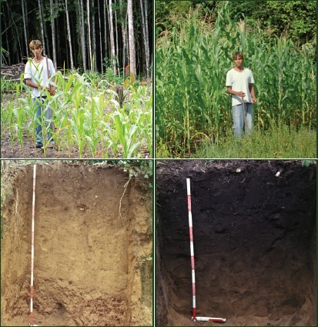
Biochar enhances soils. By converting agricultural waste into a powerful soil enhancer that holds carbon and makes soils more fertile, we can boost food security, discourage deforestation and preserve cropland diversity. Research is now confirming benefits that include:
- Reduced leaching of nitrogen into ground water
- Possible reduced emissions of nitrous oxide
- Increased cation-exchange capacity resulting in improved soil fertility
- Moderating of soil acidity
- Increased water retention
- Increased number of beneficial soil microbes
Biochar can improve almost any soil. Areas with low rainfall or nutrient-poor soils will benefit the most.

Biochar and Terra Preta Soils
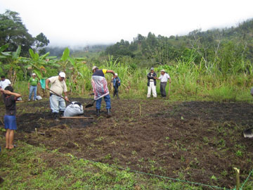
Biochar production is modeled after a process begun thousands of years ago in the Amazon Basin, where islands of rich, fertile soils called terra preta ("dark earth") were created by indigenous people. Anthropologists speculate that cooking fires and kitchen middens along with deliberate placing of charcoal in soil resulted in soils with high fertility and carbon content, often containing shards of broken pottery. These soils continue to "hold" carbon today and remain so nutrient rich that they have been dug up and sold as potting soil in Brazilian markets.

Rural and Developing Country Applications of Biochar Systems
Biochar systems can reverse soil degradation and create sustainable food and fuel production in areas with severely depleted soils, scarce organic resources, and inadequate water and chemical fertilizer supplies. By making croplands more fertile for longer periods of time, biochar discourages deforestation. Low-cost, small-scale biochar production units can produce biochar to build garden, agricultural and forest productivity, and provide thermal energy for cooking and drying grain. With the addition of an engine or turbine, these systems can produce kinetic energy for grinding grain or making electricity.
(Upper photos courtesy of Julie Major and Bruno Glaser; lower photo courtesy of Julie Major.)

Environmental Benefits of Biochar
If we want to tackle climate change challenges, we must look to the untapped potential of the soil to sequester carbon. By doing that, we are improving biodiversity of the soil ecosystem and improving the productivity of the soil, therefore impacting the livelihoods of affected populations."
Luc Gnacadja, Executive Secretary of the UN Convention to Combat Desertification (UNCCD)
Sustainable biochar is a powerfully simple tool to address some of the most urgent environmental problems of our time:

Global Warming
Sustainable biochar can be used now to help combat global warming by holding carbon in soil and by displacing fossil fuel use. Research shows that the stability of biochar in soil greatly exceeds that of un-charred organic matter. Additionally, because biochar retains nitrogen, emissions of nitrous oxide (a potent greenhouse gas) may be reduced. Turning agricultural waste into biochar also reduces methane (another potent greenhouse gas) generated by the natural decomposition of the waste. This powerfully simple tool can store 2.2 gigatons of carbon annually by 2050. Click here for more information on biochar and carbon sequestration potential.
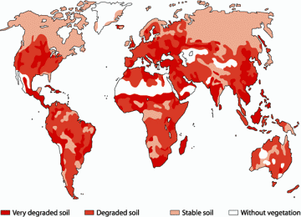
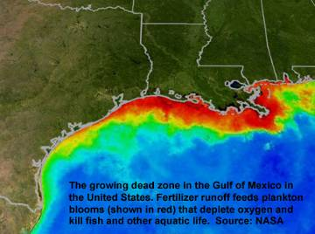

Soil degradation and food insecurity
As a soil enhancer, biochar makes soil more fertile, boosts food security, preserves cropland diversity, and reduces the need for some chemical and fertilizer inputs.

Water pollution by agro-chemicals
Biochar improves water quality by helping to retain nutrients and agrochemicals in soils for use by plants and crops, resulting in less pollution.

Waste Management
Biochar production offers a simple, sustainable tool for managing agricultural wastes. A combination of waste management, bioenergy production, and sustainable soil management can succeed with an approach involving biochar.

Deforestation and loss of cropland diversity
By converting agricultural waste into a powerful soil enhancer with sustainable biochar, we can preserve cropland diversity and discourage deforestation.

Climate Change and Carbon Sequestration

If you could continually turn a lot of organic material into biochar, you could, over time, reverse the history of the last two hundred years...We can, literally, start sucking some of the carbon that our predecessors have poured into the atmosphere down through our weeds and stalks and stick it back in the ground. We can run the movie backward. We can unmine some of the coal, undrill some of the oil. We can take at least pieces of the Earth and – this is something we haven’t done for quite a while – leave them Better Than We Found Them.”
Bill McKibben, author, climate activist and founder of 350.org
Photo: Nancie Battaglia

How Can Biochar Be Carbon-Negative?
Fossil fuels are carbon-positive -- they add more carbon to the air. Ordinary biomass fuels are carbon neutral -- the carbon captured in the biomass by photosynthesis would have eventually returned to the atmosphere through natural processes -- burning plants for energy just speeds it up. Sustainable biochar systems can be carbon negative because they hold a substantial portion of the carbon in soil. The result is a net reduction of carbon dioxide in the atmosphere, as illustrated below.
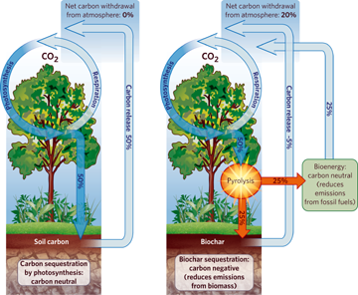
Biochar can hold carbon in the soil for hundreds and even thousands of years. Biochar also improves soil fertility, stimulating plant growth, which then consumes more CO₂ in a feedback effect. And the energy generated as part of biochar production can displace carbonpositive energy from fossil fuels. Additional effects from adding biochar to soil can further reduce greenhouse gas emissions and enhance carbon storage in soil. These include:
- Biochar reduces the need for fertilizer, resulting in reduced emissions from fertilizer production.
- Biochar increases soil microbial life, resulting in more carbon storage in soil.
- Because biochar retains nitrogen, emissions of nitrous oxide (a potent greenhouse gas) may be reduced.
- Turning agricultural waste into biochar reduces methane (another potent greenhouse gas) generated by the natural decomposition of the waste.
Diagram courtesy of Nature Publishing Group

How Much Carbon Can Biochar Remove from the Atmosphere?
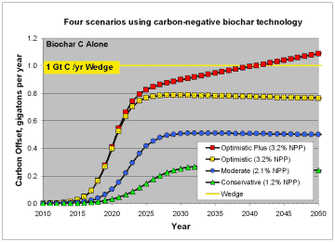
IBI has developed a simple model to predict the carbon removing power of sustainable biochar systems. The figures here show the results of this preliminary model. We expect these answers will change as more is learned about the impacts of biochar, but the model gives a sense of what is possible.
The top figure on the right shows several scenarios that assume biochar production from waste biomass only, which is a small fraction of Earth's annual net primary production (NPP). Counting only the impacts of biochar burial in soil, and without considering the displacement of energy from fossil fuels, we can conservatively offset one quarter of a gigaton of carbon annually by 2030.
Optimistically, we could achieve one gigaton of offsets annually before 2050.
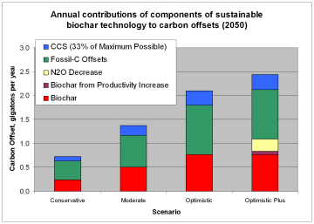
In the "Optimistic Plus" scenario, we account for reductions in nitrous oxide emissions and for the feedback effect of increased biochar production that may arise from increased plant growth in soils enhanced with biochar.
The second figure highlights additional carbon offsets possible if energy from biochar production displaces fossil fuel energy, and if CCS (carbon capture and storage) is used.
For a fuller explanation of the scenarios and references, please see How Much Carbon Can Biochar Systems Offset - and When?

Biochar Technology

One of the most exciting new strategies for restoring carbon to depleted soils,and sequestering significant amounts of CO₂ for 1,000 years and more, is the use of biochar.” “The principle barrier to the use of this strategy is the lack of a price on carbon that would drive the economy toward the most effective ways to sequester it. There is presently no formalized network of biochar distribution channels or commercial scale production facilities. But a stable price on carbon would cause them to quickly emerge – because biochar holds such promise as an inexpensive and highly effective way to sequester carbon in soil.”
Al Gore, 45th Vice President of the United States and 2007 Nobel Peace Prize Co-recipient
Photo: Paramount Vantage
There are many different ways to make biochar, but all of them involve baking biomass in the absence of air to drive off volatile gasses, leaving carbon behind. This simple process is called thermal decomposition, and it comes in three main varieties: pyrolysis, gasification and hydrothermal carbonization. These methods can produce clean energy in the form of gas or oil along with the biochar. This energy may be recoverable for another use, or it may simply be burned and released as heat. It’s one of the few technologies that is relatively inexpensive, widely applicable and quickly scalable.
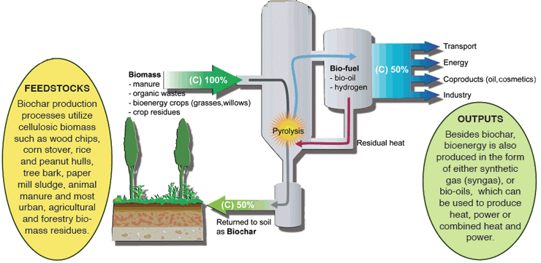
But biochar technology is more than just the equipment needed to produce biochar. Biochar technology necessarily includes entire integrated systems that can contain various components that may or may not be part of any particular system.

In general, however, biochar systems should include the following elements:
- Collection, transport and processing of biomass feedstocks
- Production and testing of biochar
- Production and utilization of energy co-products: gas, oil or heat
- Biochar transport and handling for soil application
- Monitoring of biochar applications for carbon accounting or other purposes
Biochar production diagram courtesy of Johannes Lehmann

Biochar Pathways Matrix
IBI has recently completed a matrix on biochar pathways best suited for different environments including technologies, feedstocks, by-products, sustainability issues, and advantages and challenges. If you have suggestions or additions to this document, please contact Kelpie Wilson.

Feedstocks
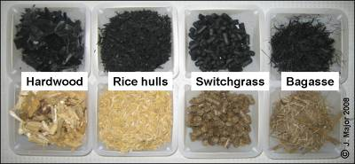
Biochar can and should be made from biomass waste materials. Making biochar from biomass waste materials should create no competition for land with any other land use option—such as food production or leaving the land in its pristine state.
Biomass waste materials appropriate for biochar production include crop residues (both field residues and processing residues such as nut shells, fruit pits, bagasse, etc), as well as yard, food and forestry wastes, and animal manures.
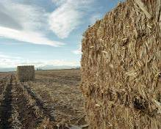
Corn Stover
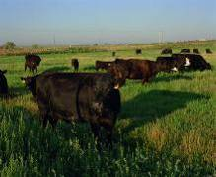
Cow Manure
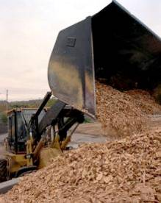
Wood Chips
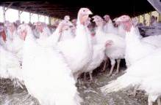
Poultry Manure
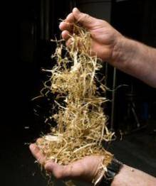
Bagasse
Large amounts of agricultural, municipal, and forestry biomass are currently burned or left to decompose and release CO₂ and methane back into the atmosphere. They also can pollute local ground and surface waters—a large issue for livestock wastes. Using these materials to make biochar not only removes them from a pollution cycle, but biochar can be obtained as a by-product of producing energy from this biomass. Feedstocks must not contain unacceptable levels of toxins such as heavy metals which can be found in sewage sludge and industrial or landfill waste.
It is important to study all the aspects of feedstock supply on a local community/business before setting up a biochar operation. Feedstock availability can vary year to year and within years. In developing country areas where feedstocks are often used as heating and/or cooking fuel, biochar production can be an important side benefit if done sustainably. The biochar can then be used on fields to potentially increase food production by improving soil fertility (See Chapter 9 Biochar Systems in Biochar for Environmental Management for a series of case studies on biochar production and sustainable feedstock models in developing countries).

Feedstock effects on Nutrient Properties of Biochar
The composition of biochar (the amount of carbon, nitrogen, potassium, calcium, etc) depends on the feedstock used and the duration and temperature of pyrolysis. As an example, biochar produced from feedstocks which have greater contents of potassium (such as animal litters) often have higher potassium contents than biochar made entirely from wood (which often have higher carbon contents). However, pyrolysis conditions greatly affect nutrient properties contents and so biochar should be tested on a batch by batch basis to determine specific properties.

Economic Considerations
The choice of feedstock will be affected by the biomass resources in the immediate area and availability. Due to collection, and transport and storage costs, it often makes the most economic sense to use local feedstocks (if they are also an environmentally sustainable option). The most basic costs and benefits to consider with feedstock choices are highlighted below:
- Feedstock production and collection: If the feedstock is a residue, such as municipal biomass waste, logging or cropping residues, or a by-product such as bagasse, then production is less an economic issue than if the feedstock is purposely grown for the production of biochar—such as switchgrass—which would include the costs and inputs needed for the growing and harvesting of the crop. Revenue in the form of tipping fees may be obtained from certain waste feedstocks.
- Use Tradeoff: This would include the potential nutrient value lost from using feedstock for biochar production rather than as a direct fertilizer on the field. How this trade off works will vary on the area and on the feedstock. For example, chicken litter may be valuable in some areas as a direct fertilizer while in other areas it may be treated as a waste and represent a disposal cost.
- Feedstock transport: When waste biomass is found far from the place where it will be used, transportation costs can be very high. In some situations it may make sense to densify the biomass by chipping or pelletizing before transport.
- Feedstock storage and pre-processing: Many feedstocks will need to be dried before pyrolysis. Depending on the feedstock choice, the drying process could occur passively through careful storage or may need more intervention—such as using a drier (thus requiring energy and labor). Energy for drying could in some cases be obtained from the pyrolysis of previous batches of feedstock.
See Chapters in Biochar for Environmental Management: Chapter 1: Biochar for Environmental Management; Chapter 5: Nutrient Properties and their Enhancement; Chapter 9 Biochar Systems; and Chapter 19: Economics of Biochar Production, Utilization, and Greenhouse Gas Offsets.

