High efficient Irrigation-System
with a very simple handling.
With optional 15A Solar-charge-controller

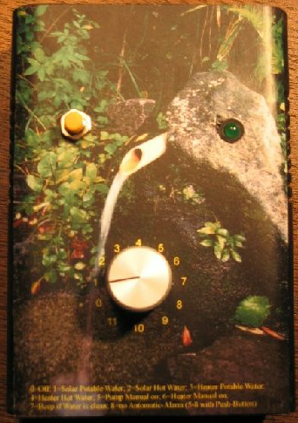
With this unit you can reduce your water demand up to 50% and you have a lot of additional features

Quick Start 2
Functions of the Program-Switch 2
Program 1: Pulsed or Trickle-Irrigation 2
Program 2: Continuous Irrigation 2
Program 3: Pump Manual Mode / Programming Battery-Type for Solar. 2
Program 4: Pump Manual on for a programmed Time 2
Program 5: Pump Manual on for the calculated Time 2
Program 6: Set days suppress irrigation 2
Program 7 Set: Set Irrigation-Time 3
Program 8 Set: Set Irrigation-Cycle 3
Program 9 Set: Set Irrigation-Time-Base (min/sec) 3
Program 10 Set: Time for Pulses Trickle-Irrigation 3
Program 11 Set: Automatic “No Water Detection” on/off 3
Solar Charge Controller 3
Deep-Discharge Protection 3
Monitor Values with LogView 4
Installation 4
Feature-List 6
How does it work? 7
Electrical Wiring / Terminals 7

Quick Start

- Connect all the cable according to the Terminal-List or Diagram

- Select your desired Program (see next list) with the Program-Switch in the middle of the Unit

Functions of the Program-Switch

0 = all is off, Alarm is Reset
1 = Pulsed or Trickle-Irrigation
2 = Continuous Irrigation
3 = Pump Manual Mode / Programming-Mode: Liquid-Lead or Gel-Type-Battery for the Solar-Charge-Controller
4 = Pump Manual on for a Programmed Time
5 = Test Irrigate
6 = Set days suppress irrigation
7 = Set Irrigation-Time
8 = Set Irrigation-Cycle
9 = Set Irrigation-Time-Base (min/sec)
10 =Set Time for Pulses Trickle-Irrigation
11 =Set Automatic "No Water Detection" off

Setting of Parameters:
If you need others than the Preset Values you can modify most of them

Program 1: Pulsed or Trickle-Irrigation
In this mode the Pump is switched on in Pulses. This reduces the water demand. If you have the Irrigation-Sensor connected, the Irrigation is suppressed if there is no demand. The irrigation will always take place at night, in order not to waste too much water by evaporation

Program 2: Continuous Irrigation
Like Program one but in this Mode the Pump runs continuously the complete irrigation-Cycle. It depends on the cultures which program is better

Program 3: Pump Manual Mode / Programming Battery-Type for Solar.
The Pump is running as long as Program 3 is activated
In the Programming-mode you select the Battery-Type for Solar. See below for more Details

Program 4: Pump Manual on for a programmed Time
In this position you can select a Irrigation-time. After this time the Pump stops. Set the Program-Switch to Position 4, press the Push-Button until the LED is fast flashing. Then select the Irrigation-Time with the Program-Switch: 1 = 10 minutes, 2 = 20 minutes etc. After this time the Pump is switched off and there is a Alarm. Reset this function with the Push-Button or with the Program-Switch at Position “0”. The fast flashing stops.

Program 5: Pump Manual on for the calculated Time
With this function you can start the Irrigation at any Time with the Time calculated by the Humidity. Select Program “5”, press the Push Button for to start this function. It stops automatically or if the Program-Selector is at Position “0”

Program 6: Set days suppress irrigation
With this function you can suppress the irrigation for defined days. Select Program “6”, press the Push-Button until the LED is fast flashing. Then you can program the days with the program-switch Position 0-11. Press the Push-button again for to save the value.

Program 7 Set: Set Irrigation-Time
Turn the Program-Switch to Position “7”
Press the Push-Button for more than three seconds. Now the LED is fast flashing
Set the Time by the Program-Switch Position 0-11 corresponds to 0-255 Minutes or 0-255 Seconds if Irrigation-Time is set to Seconds (See Programming of Irrigation-Time-Base)
Press the Push-Button for more than three seconds. Now the LED stops fast flashing

Program 8 Set: Set Irrigation-Cycle
Turn the Program-Switch to Position “8”
Press the Push-Button for more than three seconds. Now the LED is fast flashing
Set the Irrigation-Cycle with the Program-Switch. 2 means every second day for example.
Press the Push-Button for more than three seconds. Now the LED stops fast flashing

Program 9 Set: Set Irrigation-Time-Base (min/sec)
Turn the Program-Switch to Position “9”
Press the Push-Button for more than three seconds. Now the LED is fast flashing
Set the Set Irrigation-Time-Base (min/sec) with the Program-Switch. Zero corresponds to Minutes, One corresponds to Seconds,
Press the Push-Button for more than three seconds. Now the LED stops fast flashing

Program 10 Set: Time for Pulses Trickle-Irrigation
Turn the Program-Switch to Position “10”
Press the Push-Button for more than three seconds. Now the LED is fast flashing
Set the Time for Pulses Trickle-Irrigation with the Program-Switch. Two means 10 seconds on / 50 seconds off for example. Three means 15 seconds on / 45 seconds off for example. All refers to 60 seconds Time-grid
Press the Push-Button for more than three seconds. Now the LED stops fast flashing

Program 11 Set: Automatic “No Water Detection” on/off
If the Automatic no Water Detection is not necessary, you can switch it off in the following way
Turn the Program-Switch to Position “11”
Press the Push-Button for more than three seconds. Now the LED is fast flashing
Program-Switch Position “0” is off, Position “1” is on
Press the Push-Button for more than three seconds. Now the LED stops fast flashing

Solar Charge Controller
If the battery is relatively empty, the yellow LED for Solar Charging is on, all Energy from the Solar-Panel is transferred to the Battery.
If the Battery gets full, the Charge Controller switches to fast Pulsation-Mode (PWM), the yellow LED starts flashing.
If the Battery is full, the yellow LED is switched off, charging is switched off.
From Time to Time the Battery-Voltage is raised to Boost-Voltage, for to avoid degeneration of the Battery. For this Function the Battery-Type has to be programmed (See Programming of the Battery-Type).

Programming of the Charge-Controller

3: Lead (Liquid-Battery) or Lead-Gel-Battery
Select Program-Switch Position 3
Press Push-Button until LED starts fast flashing.
Then Program-Switch to
Position 0: Lead (Liquid-Battery)
Position 1: Lead-Gel-Battery
Save Settings by pressing of the Push-Button until the LED Stops fast flashing

Reload the Standard Values (Reset of all values to Pre-Set-Values)
If you press the Push-Button during Switch-on of the Device all Preset-Values will be loaded

Deep-Discharge Protection
If the Battery is empty, the Output Load is switched off delayed, the red LED is on. As a pre-Warning the red LED is flashing when the LED is relatively empty. Five minutes before the Load is switched off, the Load is switched off shortly as a Pre-Warning.
Please connect the Inverter only up to 100 Watt to the Output. Above that the Inverter has to be connected direct to the Battery. There is normally an automatic switch off integrated in the Inverter in case of low Battery.
The Transistor-Output (12V/24V) is shipped with an automatic Fuse.
The Relay-Outputs have no internal Fuse! You have to provide a external Fuse for Safety!

Alarms:
The Alarm-Horn can be reset by setting the Program-Switch to Position “0” or by Pressing the Push-Button

Monitor Values with LogView
Logview is a excellent Software (Freeware) to Monitor and evaluate Process-Data. This Device sends the Measurement-Values such as the
Humidity,
Min. Humidity
Max. Humidity
Temperature
Setpoint Irrigate
Light (lux)
Battery-Voltage
NimH-Voltage
in the Logview-Format and you can evaluate them.

Short Overview about the Features of Logview
View of Process-Data in Graphic
View of Process-Data in Table-Format
Evalate the Data in Real-Time
Comparison of Curves
The Design can be changed
Intuitive workaround
Integrated RTF Editor
Graphic-Editor
Export-Funktions:
Table-Format: CSV, ASCII, HTML, RTF und Excel
Graphic-Format: BMP, JPG, GIF und PNG

Installation
Install Logview with LogViewInstaller from the CD (Folder \LogView) or the latest Version at the Internet: www.logview.info/cms/d_logview-21.phtml

Download the file Metamor_Irrigate_Medium_e.ini from the Internet (www.alternative-technology.de and the according Application) and you have to copy it to the folder
C:\Documents and Settings\your User-Name\Application Data\LogView\Geraete\OpenFormat\

Start Labview
Select Device at Menu „Device, choose Device and Port“ the according Device Metamor_Irrigate_Medium_e
Select according serial COM-Port as well

At Menu File, Settings, Program select the following:
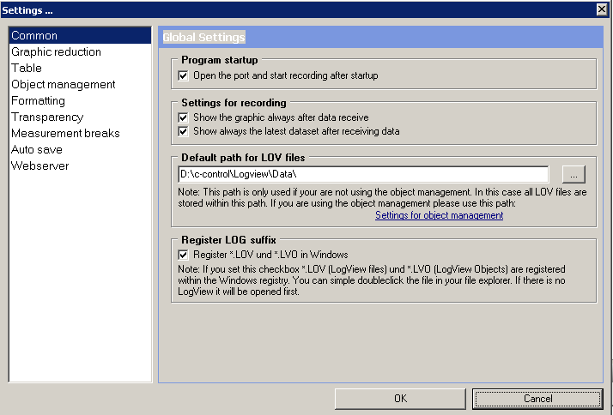

In the Default path for Log-Files the Log-Files are stored. You can modify it. These Files can be checked later on just by double-click

Registrier Log suffix should be checked that you can start Logview by direct clicking the *.lov file.

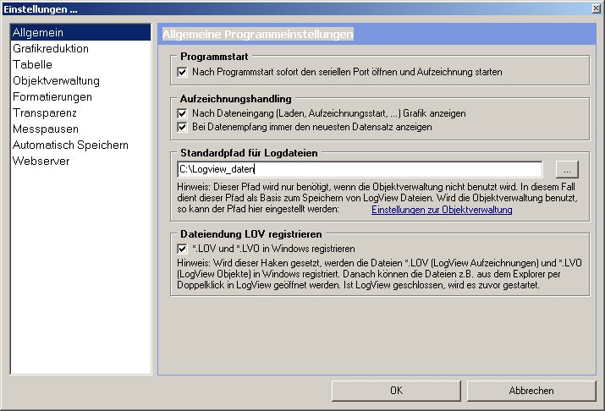

Then you can start the recording. In the Life-Window Data should come up.
If you want to have the actual Time being displayed in the Curves
Select Menu Grafic, Zeitformat der X Achse, then ontop instead of R_ make D_ and save.
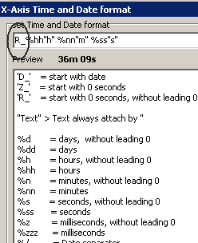
More Infos in the online-Manual of Logview and the Internet under www.logview.info

Hints and other Features

- If you press the push-button during Start-up all default values are loaded.
- If you press the push-button during Start-up you can set the Device to Simulation. That means the Analogue-values are always read. And the time is set to irrigation-time.
Otherwise the Analogue-values are updated only all minute. This is done to increase the lifetime of the Humid-Sensor.

- If you press the Push-Button by mistake and you are in Programming mode, the Mode will be disabled after one minute.
- If you use a 24V-System also the Relay and the Moving-Detector has to ordered for that voltage.
Loading of new Software
To load new Software into the Unit you have to Start the Program „BootLoader.exe“ (on the CD in the Tools-Folder).
- Connect Data-cable to Serial Port. If you have no serial Port, install the USB-serial-Adapter first.
- Start the Program, Select Options „19200 Baud“ and the according COM-Port.
- Then „File“, „Select File“ and navigate to the according *.bin file.
- Then „File“ „Upload“
- If only "Sending #123" appears, switch the Device off and on (Remove battery cable and reconnect).
- If still no Download-Window is popping up, something with the cable is wrong or with the Metamorphose

Feature-List

- Using a light sensitive Sensor Irrigation starts automatic at night before dawn, the best time for Irrigation. This works also if there are frequent Power-failures.
.
- You can select a Continuous Irrigation or a Pulsed irrigation. The Pulsed irrigation reduces the water demand and works on the effect of trickle irrigation without the high costs for such a System

- Automatic detection of no Water Flow and Alarm

- You can connect any Humidity-Sensor. But you can use a very simple Self-Made Humidity-Sensor as well or you can get one together with the Device. The Sensor is based on Conductivity-Measuring with Temperature-Compensation

- Anti-Corrosion Protection for the Humidity-Sensor

- Automatic Set-Point detection for the Irrigation-Time based on the Minimal and Maximal-Values.

- Manually Adjustment of the maximal Irrigation-Time from seconds to hours. All essential Parameters can be adjusted manually and very easy. Just press a Push-Button and program the desired Value.

- Cycle suppress of Irrigation in order to get better quality of the roots.

- System works also if all Sensors are broken. Irrigation will be started all 24 hours in this case

- Additionally Level-Sensors can be used in order to Protect the Pump from running dry

- Manual Mode for Irrigation: Switch Pump on for a Preset Time

- Manually Readjustment of the Irrigation-Cycle for example every second day etc

- You can connect 12V, 24V DC or 220V AC Pumps or Valves with max. 2200 Watt/10 Ampere.

- Very easy to handle. Just connect the Pump and Humidity-Sensor and it works. No more adjustments are necessary.

Solar charge controller
- Up to 15 Amperes Charging Power using POWER-MOFET-Transistors.

- Overcharging-Protection of the Battery by fast Pulse-Wide-Modulation. This Mode gives better charging-results than slow Pulse-charging.

- Additional Input for charging of the Batteries with a 220 V / 12V or 24V Transformer

- Boost-charging from time to time (depending from the discharging level or at least once a month). Boost-charging avoids the degeneration of Liquid-Batteries.

- 80 % of the Batterys die from a degeneration of the Battery-Plates. Due to research-work of the University of Vienna, Austria and NASA, USA, this degeneration can be reduced drastically by very short High Current Pulses to the Battery. This charge controller is equipped with this feature, to extend life-time of the Battery.

- Applicable for all Types of Lead- Batterys (Gel-Type etc.)

- Applicable for 12V or 24V-Systems. The System-Voltage is verified automatically. If you use the Relays, you have to order a 12V or 24V-Version.

Many Safety Precautions:
- High Temperature-Protection
- Reverse-Connection Protection for the Solar-Panels and Battery
- Automatic Short-circuit Protection for the Load, no more replacement of Fuses are necessary
- Over-voltage Protection for the Input of the Solar-Panels
- Protection for "no-Battery"-connection (if only Solar-Panels are connected, the voltage will raise very high)
- No Reverse-Current to the Panels at night

- Serial Interface for to Scan and Log Measurement-Values and evaluate on them on the PC

- It’s a Open-Source-Project! You can even make your own Modifications in the Software and download it.

- Very good price / performance-ratio

How does it work?

- The day-time is detected automatic by a light-Sensitive Sensor. The Time for irrigation is set to 4 o’clock at night, a good time for this
- There is a flexible Setpoint for the irrigation-time, calculated by the degree of Humidity in the ground.
- The actual value Humidity is only relevant short before irrigation, that means always at night
- Being very sensitive for Temperature, the Actual Value Humidity is Temperature-Compensated

Connection 12V/24V-Pump or Valve
  - Bridge from Terminal 4 to Terminal 28
  - Pump or Valve at 27 (+) and 32 (Minus)

Connection of a 220V-Pump or Valve
  - 220V 1. Input to Terminal 28
  - 220V 2. Input direct to Pump
  - Relay Output Terminal 27 to Pump
  - 220V Ground direct to Pump

Electrical Wiring / Terminals
Terminals left |  | ext.Wiring | Terminals right |  | ext.Wiring
1 | free |  | 21 | +5V | all ext. Sensor Output
2 | free |  | 22 | +5V
3 | Minus | Power Supply 12V Minus | 23 | Level (d.5) | Level-Sensor (optional)
4 | +12V out |  | 24 | ADC2(PC2) | Light Sensor Input
5 | +12V in | Power Supply 12V+ | 25 | ADC3(PC3) | Humid-Sensor Input
6 | +12V charge. | Charge Batt. With Transf. | 26 | ADC4(PC4) | Temperature-Sensor In
7 | Micro 1 + |  | 27 | Relay 1 NO | Relay Water Pump 1 or Valve
8 | Micro 2 + |  | 28 | Relay 1 in/d.2 | Relay 1 Input (12V/24V/220V)
9 | Micro 1 - |  | 29 | Telephone
10 | Micro 2 - |  | 30 | Telephone
11 | Minus | Relay 2 Minus | 31 | free
12 | Relay 2 NC |  | 32 | Minus
13 | Relay 2 in/b.0 | Relay 2 Input (12V/24V/220V) | 33 | Minus
14 | Relay 2 NO | Relay 2 Output (12V/24V/220V)

