Step by Step-Manual for a Solar Thermal-System

Check all Material is ok and available!

Cut 2-3 * Absorber-Sheet to 105 *81

Cut copper-Pipes 20* 1 m

Cut short copper pieces 5,5 cm for to connect horizontal T-connection

Cut 4*20 cm copper outlet

Solder copper-Pipes and T-connections and L-connections

Fix Copper-Pipes to Absorber-Sheet, drill holes, use copper-wire

Rough the surface with steel wool and clean.

Rough the surface of Absorber and Pipes with steel wool before painting.

Paint or Spray Absorber-Sheet and Copper-Pipes thin

Cut Wood

Mark the Outlet and cut hole already

Mount side-lath, and botton lath except lath with hole! Side d will remain open until the absorber can be placed definitively into the box.

Isolation Absorber: Cloth, Wool, remains of wood, Insulation-Material;
Layer: hot, Cardboard/cloth, Alu-Foil then Isolation-Material

Test the Absorber outside for Leaks by letting water go in and cover the other hole with finger to build up a little pressure

Mark where lath are and put in Absorber and screw at Lath

Strike with the glass-cutter the exact length and width of the needed glass-sheet

Make Rubber-Strips (from a Car or Truck –Tire for example) for glass 4 * 112, 4 * 88

Sealing all holes with silicone or glue etc

Nail the Rubber-Strips around the frame and let at the upper side 3 cm free for moisture to go out. Flip the rupper-strips to double and nail them all around the edge

Put all around the glass-edge silicon where the L-Angle should come

Clean the glass from both sides

Put the glass on the frame

Mount the L-Angle to fix the class

Solder the outside-Connections for the Pipe

Cover the hole around the Pipes with silicon

Prepare Tank: Inlet/Outlet and Vent

Inlet for Cold water and circulation Panel can be the same pipe with a T-Connection

Optional Cold Water Inlet at hot water Tank with flow reduction for example a T-Shape connection at the entrance.

Plastic Cold-Water-Tanks with Cover need additional holes on top for air to go in, because this Tanks are often well air-closed. Or remove the rubber sealing on the Cover.

Check Tank for leaking before insulation

Isolation of Tank: : Cloth, Wool, remains of wood, Insulation-Material;
Layer: hot, Cardboard/cloth, Alu-Foil then Isolation-Material

If possible put in optional calming metal-sheets

Cut external pipes with faucet (spanisch: grifo)

Paint Solar-Collector where wood can be damaged by rain

Installation
Location: The place should be not to far of the Shower, best on top of the roof. For not to have too much Temperature-losses by the Pipe.
The place should be shadow free
it should be at least 1 m higher than the shower and all Taps
it should not be too far away of the shower in order for not too wait too long until hot water comes. Best in roof of the house, but must be stable enough! Water-Tank weight’s up to 250 kg!

Warm-water Tank should be 50 cm above Solar-collectors and the Cold-Water-Tank 50 cm above that. Look Picture for Pipe-Connections.

The vent must be higher than the water-level of the upper Tank

Panels should slope at least a little bit upwards

Check whole System for Air-Locks, that all Pipes are going up and not a little bit up and down. All connections must slope upwards.

Check Air-Vent is open

Fill slowly with water and check all connections for leaking

Cold water Tank must have a small hole for air if it is a Plastic-Tank with a good closing cover.

Isolate Pipes: Layers: Pipe, Isolation (old cloth or wool, some mattress have cloth inside), may be fixed with cord. Then adhesive Aluminum-Foil or a Plastic-Pipe or a old stovepipe.
Optional make little holes at the lowest point for water to go out.

At the end you can paint the Hot-Water pipes and cold-water Tank black to get more Performance.

If no water is coming although there should come water check for Air in the Pipes

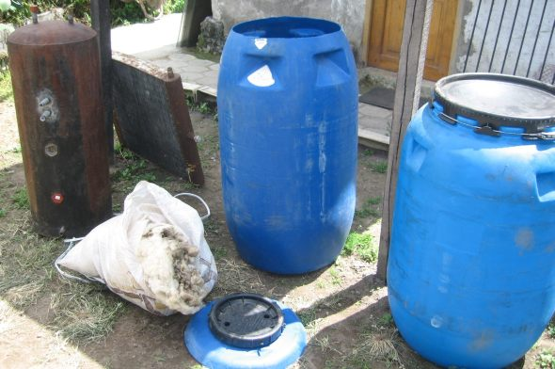
These Tanks had been used; wool for Insulation and look the Pipe connections at the Tank

Making and sealing of the wooden Box
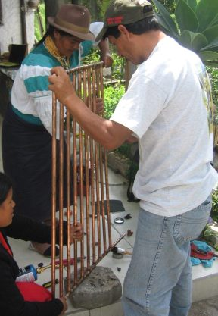Making the copper-Absorber
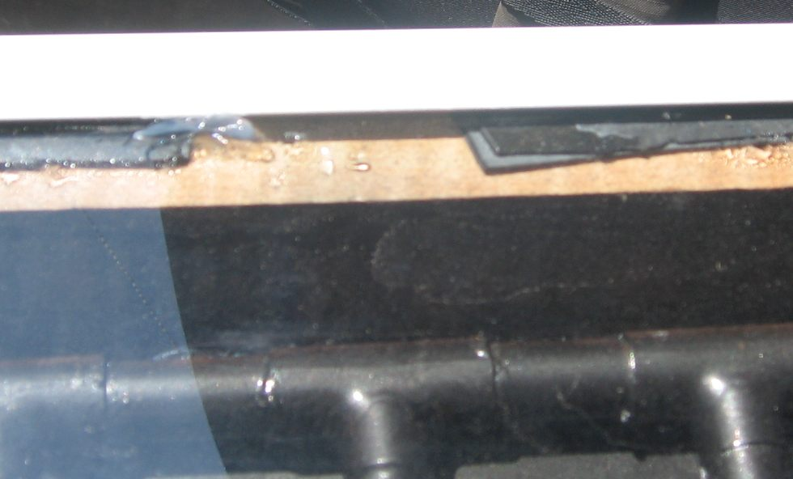
Leave a gap to let moisture to go out; Silicon at glass-edge before glass and angle is mounted

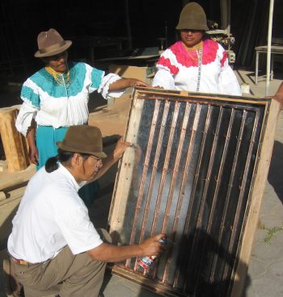
Spray with dull black colour

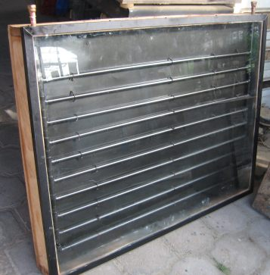
The collector is ready!
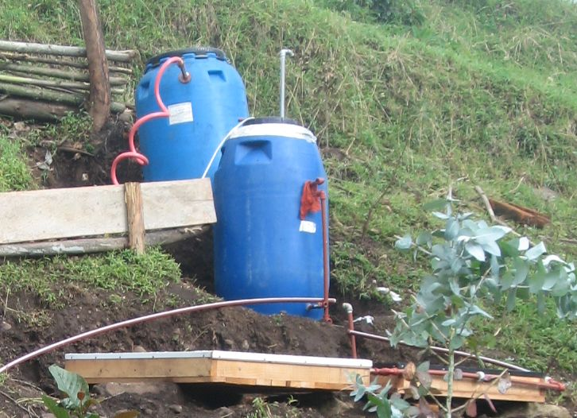during Installation

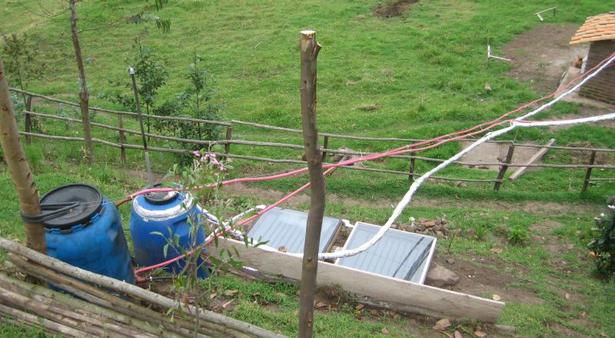
Ready! Let’s take a Sun-Shower!
In the morning and at cloudy days there was still warm water!

