Solar-Dryer-Project in Ecuador, St. Clemente (near Ibarra)

This dryer was built in a workshop with several Indian in one day. Our cost had been about 70 $. The people had been very much fascinated from this technology and had many ideas about using that Dryer and wanted to build more by themselves.

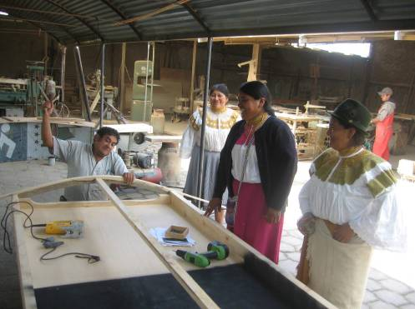
We had good support from skilled people

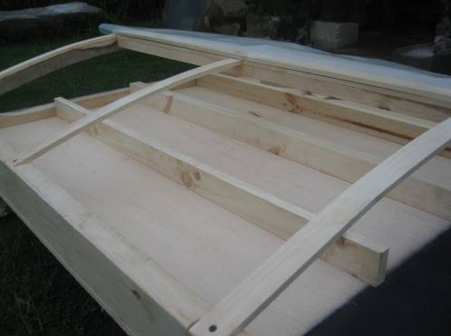
On the wooden bars a metal grating, grille for to hold the food is placed.
In that way the air can come from below as well

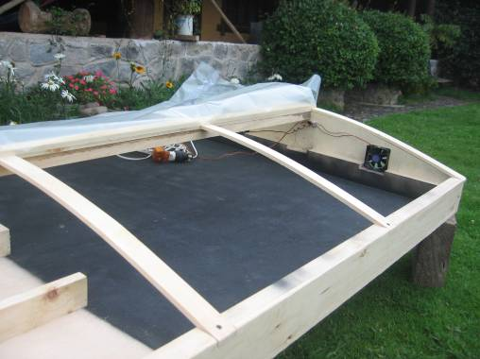

One side is dull black and we made two fans for air-circulation with a adjustable Power-Supply

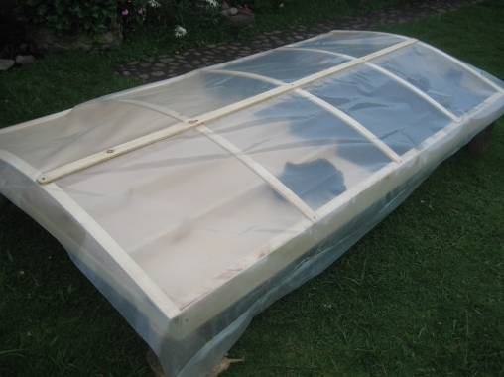

Covered with a plastic sheet which is used normally for glass-houses

More information:
Alternative Technology
Stefan Schranner
Frau-Holle-Weg 28
97084 Würzburg
Tel: +49 (0)931 72353
Mobil: +49 (0)152 54690448
Email: StefanSchranner@yahoo.de
Internet: www.alternative-technology.de

