Solar Home Power Supply with Batteries combined with Mains Power-Supply

Background
Having a Solar-System helps you to reduce the energy-costs and is also a backup-system in case of Power-failure. But to increase efficiency it is good to use as much energy as possible direct without loading the batteries, because this produces some losses.
This is one concept how to combine and manage both energy-sources, Solar-Power and Mains Power-Supply.

Features
- Automatic switch over Mains Power-Supply to Solar-Power depending from the Battery-Status and Inverter-Status (overload).
- Interlocking switch over Inverter and Mains by two Switches.
- Charging of the Batteries by Solar-Power with a Charge-Controller
- Charge of the Batteries by a external Battery-Charger from Mains in Case of Solar-Energy is available (using a LDR-Sensor). This is a option if you have a grid-connected system.
- Switch off Inverter if not in use to save Power.
- Fridge, Deep-freeze, Washing-machine and Dish-Washer can also be controlled by Metamorphosis, that they start only from 11:00 till 15:00 and not all at the same time.

Overview Hardware
- You need two Relay (24V coil-voltage) with 3 switch NO (if 3 Phase) and 1 NC-contact, one relay 2 KW, the other one 3-4 KW (due to max. consumption in the house)
- One electrical counter with Pulse output
- Two 24 V / 1 A Power-supply
- Inverter, best is Sinus, may be 2000 W
- Charge-controller and Management-System Metamorphosis
- Solar-panel and Batteries
- Appropriate cable

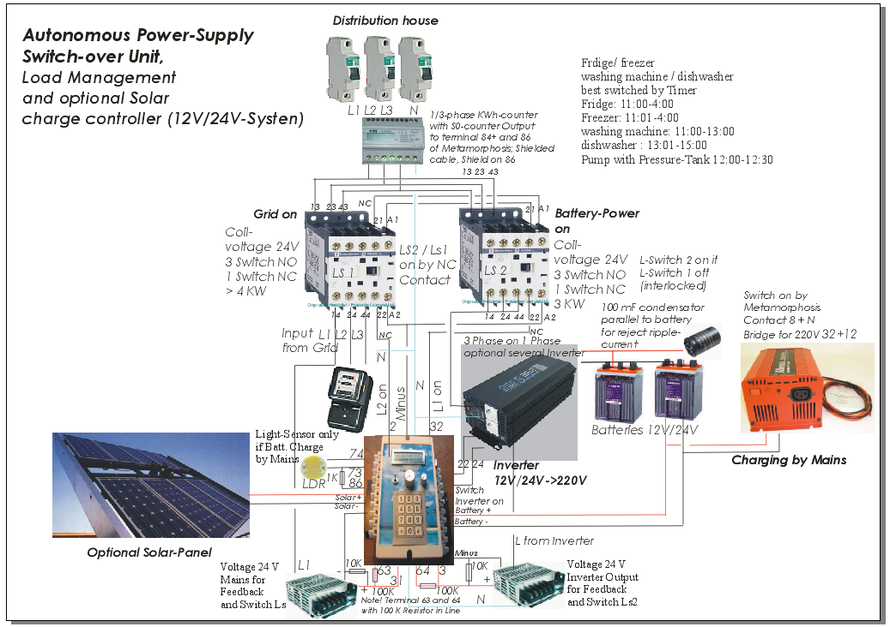

Overview channels and realization
The functions are implemented via the universal modules of metamorphosis. This opens maximum transparency, flexibility and adjustability.
The modules can be monitored and modified by menu 1 (press key “1” after switch on).
- Channel or module 1-8 manages the switching of Power between mains and battery and vice versa.
- module 9-14 manages the various appliances (refrigerator, freezer, etc.) that they are activated at the time of most solar yield.
- With module 15 you can activate a charger for the batteries when the sun shines. This could be interesting for a solar feed-in to mains-version. A light sensitive sensor (LDR) is required if the device works without solar cells.
- With module 16 an additional device can be activated if the batteries are full.
- The other channels are related to load shedding at 12 V or any other functions.

Loading the Data of the universal modules to the Metamorphosis
The data from the Excel spreadsheet of universal modules can be transmitted to the controller. A text file is generated first which is loaded to the Metamorphosis by the MP _remote-program.
1. Exporting from Excel: Down at the table there is a button "Export Data to send". Push this button and the data are exported to a text file.
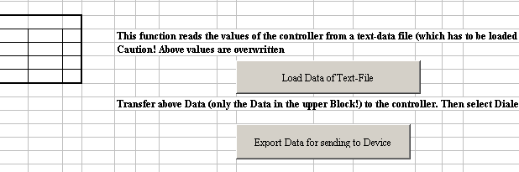
2. Connect the metamorphosis by the cable to the PC and switch it on. Transfer the Data to the metamorphosis by calling C:\Metamor\MP_Remote.EXE.
Selecting language and at "Software" is the right software "charge controller"
Set the COM interface properly
Transfer the Data by “Data” "Send data universal module to Metamorphosis".
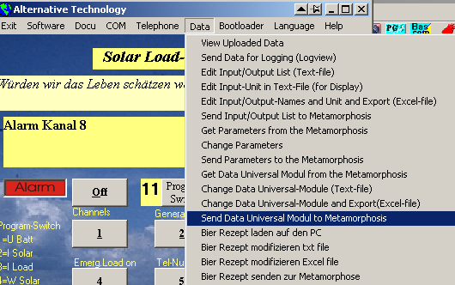
Wait until the process is completed by display on the LCD display.

Conversely, the data can also be uploaded from the controller to the PC (a text file). This is done by Menu "Data", "Get Data Universal-Module from the Metamorphosis". This text file can then be imported to Excel by the button below "load data of text file".

You can specify text for the inputs, outputs and messages. These are defined in Excel first Sheet “input/Output” There you can set the names for the inputs and outputs in the first sheet where output 17-24 can be a free alarm text for SMS.
This can be loaded into the device to display the alarm and information.
Export these texts with the button "Export to text file for sending" in Excel.
Then transfer it by the MP_Remote Program, Data, "Sending input / output list to Metamorphosis,". Wait until Metamorphosis shows “ok”.

Details of the functions for autonomous power supply

Channel 1. Switch to grid if the battery is empty (not completely empty).
Low battery voltage delayed switches to grid. With a hysteresis and a delay switch back to battery mode. The Metamorphosis has to be powered by the Batteries, to measure the Battery voltage. This function requires a Battery-powered Backup-System.

2. Switch to Battery-Power if the inverter is ok (no fault and or over current).
Delayed switch to inverter mode if he runs again.
If the inverter does not have an output voltage (over-current or battery empty or manually off), then it will be switched to the Mains. It needs a 24 V transformer as feedback from Inverter and for the Switch.

3. Turn on Refrigerator / freezer / washing machine / dishwasher at sunshine time only.
Timer triggered from 11:00 to 15:00. First refrigerator, freezer, washing machine then then dishwasher f.e.
Switching the fridge on only at daytime for some hours is possible, because the cooling energy stays for several hours if it is good isolated. But you have the problem that if you open the fridge at the evening, the light will not be on. May be a small battery-driven light will help. How to keep cold energy a long time in the fridge?
Use latent heat (Wikipedia: http://en.wikipedia.org/wiki/Latent_heat)
Latent heat storage works through the use of solid-liquid phase transition (freezing-melting). When charging the latent heat storage frozen salt mixed with water are melted (storage medium) and reverse. They absorb and release a lot of energy by that.
Calculating the amount of the salt:
If you multiply -15.71 g / ° with the desired freezing point you get the amount of salt per kg of water.
Example freezing point -18 ° C
m = T x (-15.71 g / °)
m = -18 ° x (-15.71 g / °)
m = 280g
Use about 280 g Salt per kg of water. The freezing point would be at about -18 degrees.
According to some Internet-sources, temperature of 10 °C in the deep-freeze is pretty enough (official is -18 °C for restaurants etc).

4. Switch to battery power during power failure (grid power monitor).
In this case the voltage of the battery is discharged a little bit lower than in the normal mode. Voltage sensor is a 24 V / 2 A power adapter which also is necessary for the Power-Switch. The battery voltage is monitored and turned off if the battery is fully empty.

5. Additional Device on if the battery is full, e.g. a Dryer.

6. Refrigerator / freezer turn on if the temperature is > X ° C.
One (Radio-) temperature measurement has to be put in the refrigerator. It turns the fridge on at critical temperatures.

7. Charging the Batteries by grid and a external Battery-charger if there is sunshine and the batteries are not full. The sunshine is detected by a light sensitive Sensor (LDR). Setpoint for the LDR has to be Setup by testing. (See channel 12)

8. Inverter on only if Battery-Power needed, to save Power. For example can be switched off in the night.

Remark
Switching from Solar-Power to Mains and reverse is proceeded in Milliseconds. Switching by Power-Failure-Mains takes a bit longer.

See the Excel-Sheet for the according functions.
Hint
Fridge, Deep-freeze, Washing-machine and Dish-Washer can also be managed better by an external Timer, because wiring is more easy. These Units can get activated every day independent from sunshine, because they need to be on at least once a day. May be washing machine can be shifted to a sunny day.

Proposal how to start the Devices:
For example: 11:00-15:00 Fridge
11:01-15:00 Deep-freeze
11:02-13:00 Washing-machine
13:00-15:00 Dishwashing-machine

How to use it?
Make wiring according Plan.
Export the Excel-Sheet using the button “Export Data for sending to Device”
Download the Data to the Metamorphosis using Program c:\Metamor\MP_Remote.EXE
And there “Data”, “Send Data Universal-Modul to Metamorphosis”.
May be download latest Version of MP_Remote from
http://www.alternative-technology.de/Download_and_Links/download_and_links.html#Dialer

Contact
Stefan Schranner
Frau-Holle-Weg 28
97084 Würzburg
Telefon: +49 (0)931 72353
Mobil: +49 (0)152 54690448
Email: StefanSchranner@yahoo.de
Internet: www.alternative-technology.de

