The Metamorphosis

One device , countless applications

Background:
We often hear of astonishing new developments. For example a tennis racket with integrated microprocessor etc. The fundamental problems of the world however look completely different. It is estimated, that over 70% of the illnesses in the developing countries are caused by unclean water. On the other side deforestation for firewood and excessive irrigation causes disastrous environment-damages. With this electronic device (called Metamorphosis) you have various ways on the way to persistent development

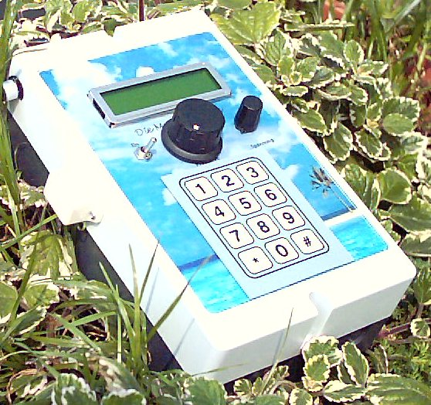
Example: Solar-Charge-Controller as a “all in one-Solution”
In many rural areas there is no electricity at all.
With the Metamorphosis you realize a Solar-System with a lot of additional Options
- Solar charge-controller with up to 60 A, overcharge and over-discharge-protection in several Steps
- loading-unit for NiCd, NiMH-Batteries
- Charging the batteries from Mains Power-Supply as well
- High grade theft-protection for the Solar-panels including Telephone notification
- different output voltages (3V/5V/9V/12V, 2A) for small appliances like Radio, CD-Player, TV
- integrated Data-Logging (Voltage, Current) for more than 30 days and Computer-interface for data-transfer
- Optional Managment of a Solar-Hybrid-System. Start/Stop a Generator depending from Battery-Status and external Events (Mains fault etc)
Many more options like Display and Modification of all relevant Parameters, fully Remote-Control of all Functions by Telephone or Mobile-Phone, Timer-controlled output, Energy-optimized sun-tracking of the solar-cells etc.

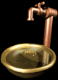
Example: Irrigation-system
70% of the water human uses is for irrigation. Using a intelligent irrigation-system, you can save more than 50% of the water.
- four independent programmable irrigation-channels for irrigation pumps or valves
- Direct connection of Pumps with up to 1000 Watt, three-Phase Pumps up to 3000 Watt
- You can connect simple and cheap humid-sensor. Integrated Temperature-Kompensation and Anti-Corrosion Protection, Arithmetic mean-Value.
- Input of a daily irrigation-time and an irrigation-duration (seconds until hours)
- You can also select a interval (for example all 5 minutes for 10 seconds ec). This function works like a easy to realize trickle irrigation system, which saves you a lot of water.
- A lot of additional Functions like Level-Control for the Water-Tank, Temperature-Control for a Glass-house
- Fully Remote-Control by Modem or Mobile-Phone
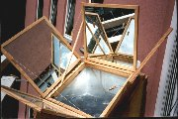
Example High Performance Solar-cooker:
Many solar-cookers exist already world-wide in order to prepare meals. Such a solar-cooker can be used quite well, in order to produce potable waters simultaneously. This can be realized very efficiently with the pasteurization-procedure. On the other side with the Metamorphosis you can cook your meals with the solar-cooker now day and night, you need not open to know when the food is ready, there is a anti-theft protection, you can say when you want to have the food ready and many more features!

Main-Aspects of the Metamorphosis:
Reliability. Many precautions are taken that you can not destroy the device
Simplicity. All important functions can be activated through one single program-switch.
Flexibility: Anyway, these are some options with the device. But if you have more ideas, let us know and we program it! And all the Software.- and Hardware-Modules can be combined the way you want. For example the solar-cooker with the telephone-call module. There will be a alarm on the handy, when the meal is ready. And you can do your programming as well. It is an open System (Open Source) and you get all necessary Software and Hardware
The Metamorphosis is one of the most fascinating processes in the nature. A creature changes completely the shape in a unbelievable manner. This electronic device can change it's functionality completely if you reload another Software. This can be done very easy through a PC.

More Software available:
-Alarm-system with a lot of additional functions:
Telephone-notification with up to three numbers; connection of any movement-detector, Sensors for water-alarm, fire-alarm etc;
When there is alarm, the telephone-numbers are called, then you can hear what happens at home, then the thief can be shocked if you speak to him through the Metamorphose, and finally a alarm-horn or something else can be activated through the telephone.
- Emergency-Telephone-Caller: For old or sick people using any remote-controller
- Business-area-supervision: If somebody comes into the store, the Handy rings
- Supervision of the your children with telephone-notification, hearing and speaking to them
- Controlling of the television-consumption of the children with different time-accounts
- Software for brewing beer (in the solar-cooker or in the washing-machine!) Temperature and time-control including refrigeration for a Mini House-Brewery
- You can have a radio-transmission version for all Sensors (up to 100m)
- Logging of up to eight measurements. Transfer of the data to the PC and evaluation
- Switching of different devices by a remote-control (Telephone or Mobile-Phone)
- Automatic switch on and off of the cordless telephone to reduce the radiation
- Illumination-control with a programmable brightness-control

Medical applications: Differential-blood-cell-counters: In the laboratory, the percentage of the Leukozyten etc often must be counted in the blood. This can be done with this appliance very easy and comfortably

– one example how fast a project (using this universal Standard Hardware) can be realized: From the idea (reducing the energy-consumption of a hot-water-tank), to the realization (installation of Hardware, Software, Tests, Optimizations) it takes only 5 days! So there is a Software now for a intelligent control of a hot water tank to reduce the energy considerably, (hot water is produced only if there is somebody!).

Further Details: The Metamorphosis consists (Max.Values) of the following Hardware (Hardware V10):
- The M128L from Atmel is the absolute Killer-Processor; RISC-Architecture for fast executing of the Program,
128 Kbyte Flash, 4 Kbyte EEPROM, 4 Kbyte RAM
- 8 Potential-free Inputs, 6 Relays-Outputs (up to 16A), 1 Power-MOSFET-Output onboard
(all Relays-Output could be Power-MOSFET or Triac as well)
- two times Double-Relays for left/right Positioning etc.
- 15 Analog Inputs with 10bit Resolution, could be used as Digital-Inputs as well. Including four Analog Inputs with additional variable Amplifying
- Additionally 12 free Ports. Could be used as Input / Output
- Three fast Counter for multiple use
- Up to 8 PWM-Outputs
- I2C-Protocoll. With that easy extension of Input / Output / Analog (up to 128 Digital Input / Output / Analog)
- RC5/RC6 IR-Remote-protocol
- 2 serial Ports (USART)
- integrated Beeper
- You can save up to 7400 Values on chip and upload it later on with the PC (cable and Software is included)
- Fully Remote Control of all Function (including switching Outputs) via Modem, GSM-Handy, or direct Cable
- Send SMS for Alarms, Receive SMS for Switching Outputs
- Power-Supply 10-30 V from solar-cells or lead-batteries or NiCd-Batteries or Transformer
- 2x16 character LCD-Display, keyboard with 12 keys
- Program-selector with 12 positions
- NiCd, NimH-Battery Loading-unit
- Additional lead-battery load-controller (max. 2A)
- Up to three voltage sources (3V/5V/9V/12V, 2A) for small-appliances like Walkman, CD-Player etc
- Telephone calling device (calling up to three numbers)
- Integrated noise-detection-device
- Room-Supervision with a built-in microphone
- NF-Amplifier for a Loud-Speaker
- PC-Cable for loading Software, Remote Control and your own programs
- The Processor is programmed with the easy Programming Language “Basic”
- Free Design of the Front. Send us your picture and we use it. Or select one of our Picture-Library

You will find much more information about the device “the Metamorphosis” in the Internet www.alternative-technology.de and you download Information and Software from there as well!

Fair-Trade-Guarantee: All appliances are produced exclusively in handwork and from unemployed academics!

Contact: Stefan Schranner
Frau-Holle-Weg 28
97084 Würzburg
Telephone: 0931 72353
Internet: www.alternative-technology.de
Email: StefanSchranner(at)yahoo.de

